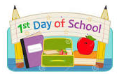
First Day of School
Where do I go?
Please arrive at your classroom door. If you are unsure where to go, there will be directions from the main office.
What will happen?
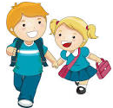
The teacher and teaching assistant will be there to welcome each child into their new class. There will be a selection of toys for the children to choose from. Encourage your child to carry their own items. If they have a coat, it is easier if they wear it, so they have their hands free to carry other items, such as, their book bag and drink.
Leave as soon as you can, as this will help your child to settle in. If you have any concerns about your child leaving you, please have a chat with your child’s class teacher who will be more than happy to help.
For more information about the school day please refer to the ‘A day in the life of…’ section.
What time is the school day?
The classroom doors open at 8.50 am and shut and 9.00 am. Please don’t come too early or late as this can unsettle the children. The school day finishes at 3.05 pm.
Drinks and Food
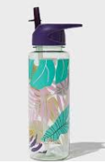
Water Bottles
Please make sure your child brings in a water bottle every day, filled with plain water. It should be a sucker topped style bottle, to avoid spillages! Encourage your child to carry their drink bottle in separately, once again to reduce spillages in the book bags.

Fruit
Everyday there will be free fruit. There will be a picture in the window to tell you what the fruit of the day is and what the fruit will be for the day after. Your child will be encouraged to try it, and if they really don't like the fruit for the upcoming day, please send in a labelled alternative which can be any fruit or vegetable.
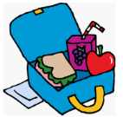
Lunches and Milk
Please see ‘Frequently Asked Questions’ for more information.

School Uniform
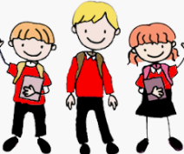
Naming School Uniform
Please make sure everything is named. Including hats, gloves, scarves, coats, shoes and PE kits.

Jewellery
No jewellery is allowed in school, however if your child already has earrings please send them in with studs only and you will need to provide tape to cover the earrings for PE.

Purchasing School Uniform
For further information on school uniform, such as, where to purchase it and PE kit requirements, please see ‘Frequently Asked Questions’.

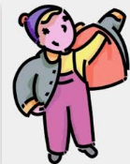
‘Being Independent’

Clothing
Please teach your child how to put their coat on and fasten it. They also need to be able to put on their own shoes, socks, jumper and gloves.

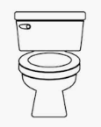
Toilet
Your child needs to be able to use the toilet independently, pull the flush and wash their hands before they start school. Please utilise the time over the Summer holidays to reinforce good toileting habits. If you have any concerns over toileting please talk to your child’s class teacher.

Health Concerns
Medicines
If your child requires medicine, such as an inhaler or eye drops etc, please pop into the school office where you can safely leave your child’s medicine and fill in an administer medicine form. For oral antibiotics, these will only be administered in school, if your child requires treatment four times a day.

If your child has any major medical concerns, such as, seizures or severe allergies, please contact Mrs Darch via the school office who can arrange a time to discuss your child’s medical needs in more detail.
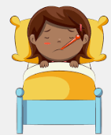
Stomach Bugs
Please remember we have a 48 hour clear period before your child can return to school after a sickness bug.

Head Lice
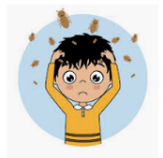
Please check your child’s hair regularly for head lice and tell the school if your child has them. To avoid head lice, we ask all children who have hair longer than their shoulders to have it tied up every day.

COVID- 19 symptoms – If your child has a high temperature or persistent cough then we ask that a PCR test is done. Your child will be sent home if they display these symptoms.

Ways to help at home
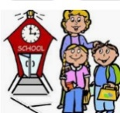
Punctuality

Please attend school on a regular basis and on time! If your child arrives late, or they take unnecessary days off this will have a negative impact on your child’s progress at school.

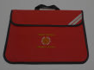
Bookbags
Please bring in your book bag every day as this will allow your child to change their reading books daily.

Parentmail
Letters are now sent to parents via email so if you have not yet been able to sign up, please contact the office to sign up for ParentMail. We can send out paper copies if you do not have an email. These letters will contain important dates and information - keep these in your diary!

Welcome Pack
Don’t forget to come to the school office to collect your child’s pack during the week commencing Monday 12th July between 9am and 3pm. In the Autumn Term you will have the opportunity to attend a ‘Curriculum Evening’ which will teach you all about how to support your child in different areas of the Early Years Curriculum.

Sharing Work From Home
We use the ICT programme called ‘Tapestry’ to share your child’s learning with you. It also allows you to upload any super work your child has been doing at home. If you have not already filled in the tapestry permission slip, please contact the office to obtain a copy.

In your home school link book, please also use the ‘WOW’ box to share and celebrate any special achievements. Such as, learning to ride a bike, which your child can share with the class.
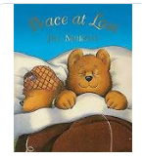
Reading
Library Book
Your child will start by bringing home a library book which they will change once a week. It must be kept in the book bag ready to change. This is a book for you and your child to share at home.

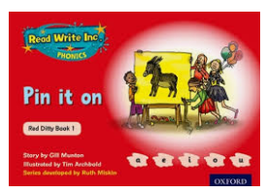
Reading Book
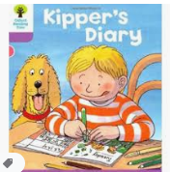
Once your child has settled into school they will start to bring home a reading book, matched to their ability level, which will be changed daily, if they have read at home.
Ideally please read with your child every night and write in the home/school link book how they got on.
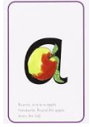
Phonics
As part of our Read Write Inc. programme a sheet of sounds the children have been learning in school will be sent home at the end of each week for you to practise with your child along with letter formation practise.

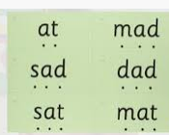
Keywords
This is an additional individual programme to support children's reading and writing. They need to practise reading the key words at home. The class teacher will aim to have the key words checked as often as possible.

What Happens Next?
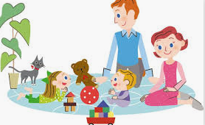
Visits To School
During the first week of school in September, there will be an opportunity for your child to come into school to meet the teacher and teaching assistant. The children will come into the class to play and parents will have the opportunity to meet other parents for tea/coffee in the school hall.

Meet the Teacher
In the first week of the Autumn term in September, you would normally have a home visit. Unfortunately, due to covid restrictions we will be unable to carry these out this year. Instead you will have the opportunity to visit your child’s class teacher and teacher assistant in their new classroom. This meeting will give you a chance to talk through any issues or concerns you may have and for your child to get to know their new teachers.
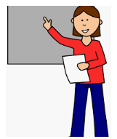
Information Evening
The teachers will deliver a presentation about starting school and will hopefully answer all the questions you may have.

What Day Does My Child Start School?
You will receive a letter in May informing you of your child’s class teacher, the date of their stay and play session, meet the teacher session and formal start date.

