Can you work out which two animals have been put together to make a new animal?

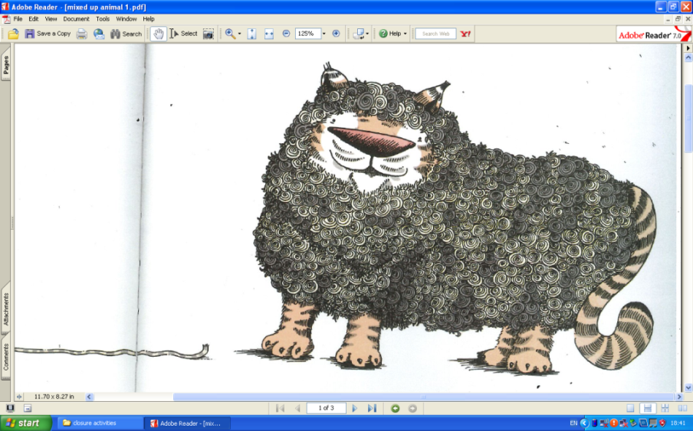

The Shiger is grandma’s favourite animal. It’s stripy wool makes the greatest jumpers.

The Horsidile has a scaly skin and it’s tail is the longest I have ever seen! It is the fastest animal on land and sea.

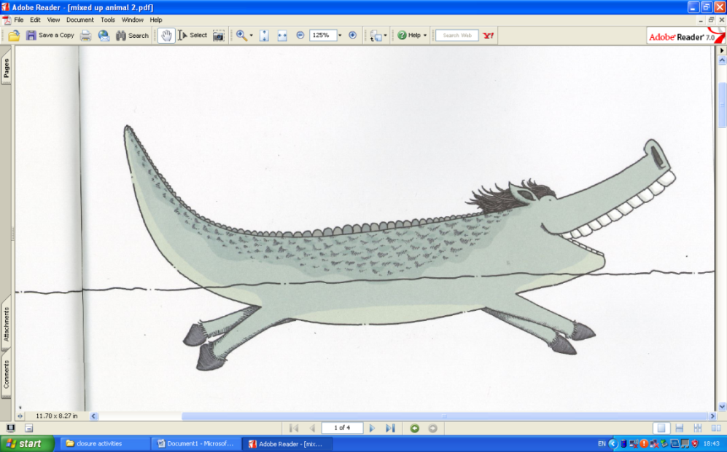

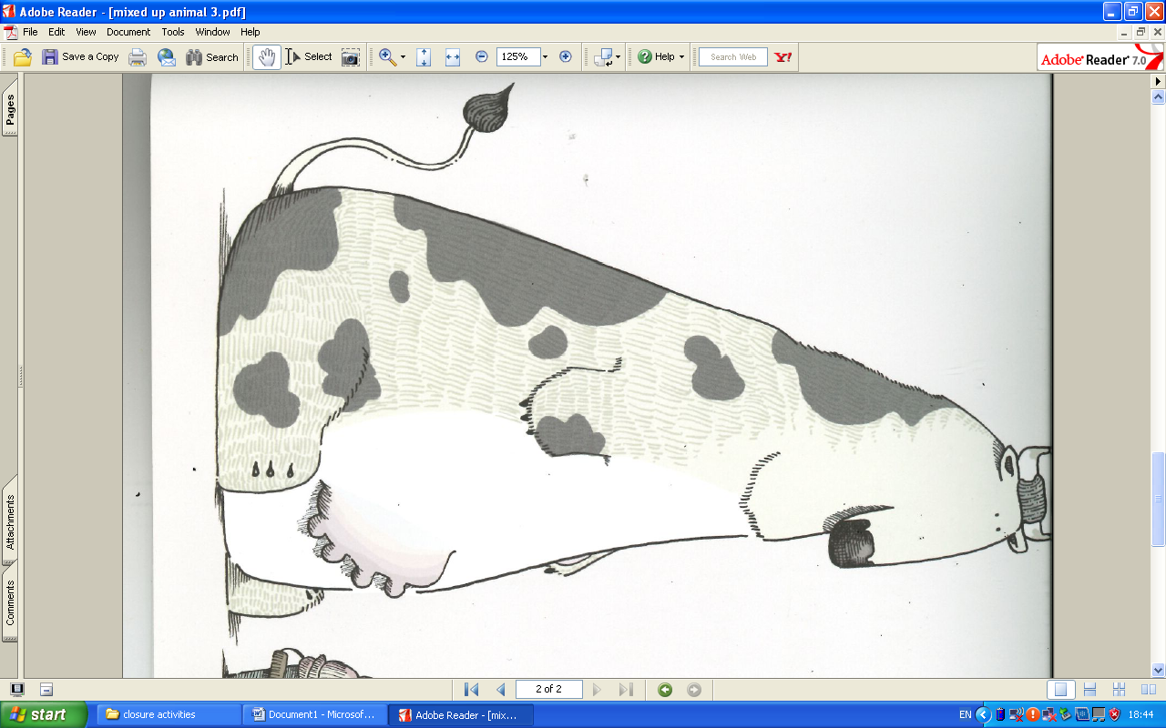

The Polar cow has sharp horns and the softest white fur. It lives in one of the coldest seas.

|  |
| --- |
| Can you draw your own mixed up animal using wild and farm animals and write a description |

My animal is called ________________________________________________________________

|  |
| --- |
|  |
|  |
|  |
|  |
|  |
|  |
|  |
|  |
|  |

|  |
| --- |
|  |
|  |
|  |
|  |
|  |
|  |
|  |
|  |
|  |
|  |
|  |
|  |