All Creatures Great And Small
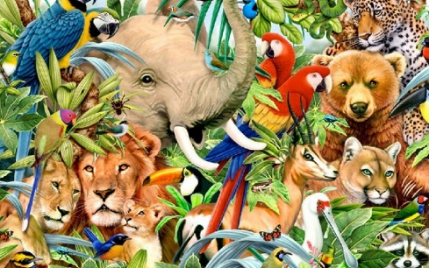
(6 weeks) Spring 2
Rationale
Following a visit from the Crazy Creatures company the Year 1 children are inspired to find out more about different animals. They will be identifying different types of common animals and sorting them into animal groups as well as learning about their different body types and what they like to eat. They will also be looking at the art work of Eric Carle and using different mediums to create their own animal picture in his iconic brightly coloured style. The children are also going to create and describe their own animal.
Hook  Children visited by ‘Crazy Creatures’ and introduced to a range of different animals. They are offered the chance to touch, hold and ask questions about these animals. |  |  |  | Outcome  The children will choose their favourite animal to create a riddle about and share these with children in Foundation.
Key Texts
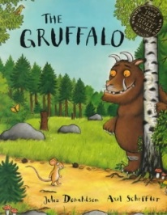  The Gruffalo – Julia Donaldson | 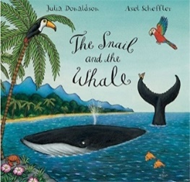  The Snail and the Whale – Julia Donaldson |  | 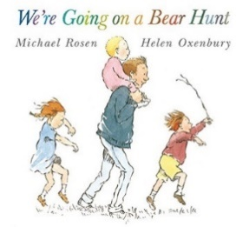  We’re Going On A Bear Hunt – Michael Rosen |  | 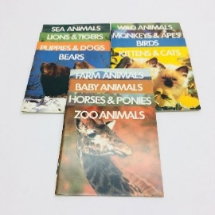  Non-fiction animal  texts |  | 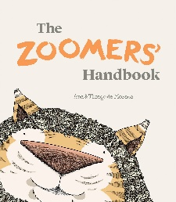  The Zoomers Handbooks-  Ana and Thiago de Moraes | 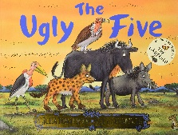  The Ugly Five- Julia Donaldson
Focus Subject – English  - Write descriptions of the animals from the Crazy Creature visit using adjectives and the conjunction ‘and’.  - Write a riddle using appropriate descriptive and scientific language, describing an animal of their choice. Also demonstrating the use of question marks.  - Design, label and describe own Gruffalo with different animal parts using plural nouns to describe e.g. claws, tusks and the conjunction ‘and’.  - Describe and compare the snail and the whale using ‘er’ and ‘est’ suffixes.  - Use a story map to retell ‘We’re going on a bear hunt’. Use this map to innovate the story to create own ‘animal hunt’ story.  - Use the Zoomers handbook to create own animal and write a description about it, using the suffix ‘ing’.  - Using non-fiction texts and information learned throughout the topic. |  | Focus Subject – Science  - Identify and name a variety of common animals including fish, amphibians, reptiles, birds and mammals.  - Identify and name a variety of common animals that are carnivores, herbivores and omnivores  - Describe and compare the structure of a variety of common animals (fish, amphibians, reptiles, birds and mammals, including pets) |  |  |  | Focus Subject – Art  Create own animal picture using a variety of mediums, inspired by the artistic style of Eric Carle.  - Use a range of materials creatively to design and make products.  - Use drawing, painting and sculpture to develop and share their ideas, experiences and imagination  - Develop a wide range of art and design techniques in using colour, pattern, texture, line, shape, form and space  Learn about the work of a range of artists, craft makers and designers, describing the differences and similarities between different practices and disciplines, and making links to their own work. (Eric Carle)
Application Subject – Computing
Children to use their computing on Purple Mash to record data using a Pictogram. Children will also learn simple programming and debugging skills through Lego Building.
Application Subject – Music
Children to explore pulse, pitch, rhythm and melodies through Charanga teaching. Children to improvise their own music using their voices, tuned and untuned instruments.
Home Learning – Children to create an animal of their choice out of recyclable materials. Children to then research and write facts about this animal, presenting them in a way of their choosing.
Trips and Visitors –Crazy Creatures Visit

