Christchurch Infant School
Addiscombe Road, Christchurch, Dorset, BH23 2AE
Telephone: (01202) 485851 Fax: (01202) 479149
E-mail: office@christchurchinf.dorset.sch.uk
Headteacher: Mr D Baxter
Deputy Headteacher: Mrs Simpson
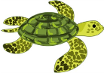
EYFS Newsletter

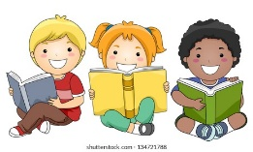

Dear Parents and carers, 12.10.21
Thank you to those of you who were able to attend our parent’s reading workshop a few week’s ago. We hope you found it useful and provided you with ways to support your child’s reading at home.
We understand that some of you may not have been able to make the workshop so we have attached some important materials to the email for you to look at in your own time.

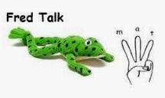
Fred Talk – Oral Blending
This sheet has a variety of games to support oral blending. This is when a child hears some sounds said separately, such as m-a-t and blends, (puts,) them together, to make the word mat.

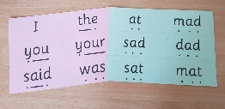
Red Tricky Key Words
This sheet gives you ideas of how you can help your child learn the tricky red words. Your child’s key word bag will be sent home before half term ready for you to practise their key words at home.

Read Write Inc. Sound mat
In school, the children use this sound mat to help them write each letter accurately. For example, if they wanted to write the word ‘pig’, they would hear ‘p’ and find it on the alphabet mat. Using the corresponding RWI phrase, the children would then copy the letter onto their own sheet saying the phrase. The RWI phrases to match each sound can be found on the attached, RWI phrases sheet.

If you would like to view the power point shown on the evening or to see any further information please visit our school website.www.christchurchinf.dorset.sch.uk
Kind Regards

Mrs Ladyman, Miss Ashbee and the Early Years Team.

