Explorers
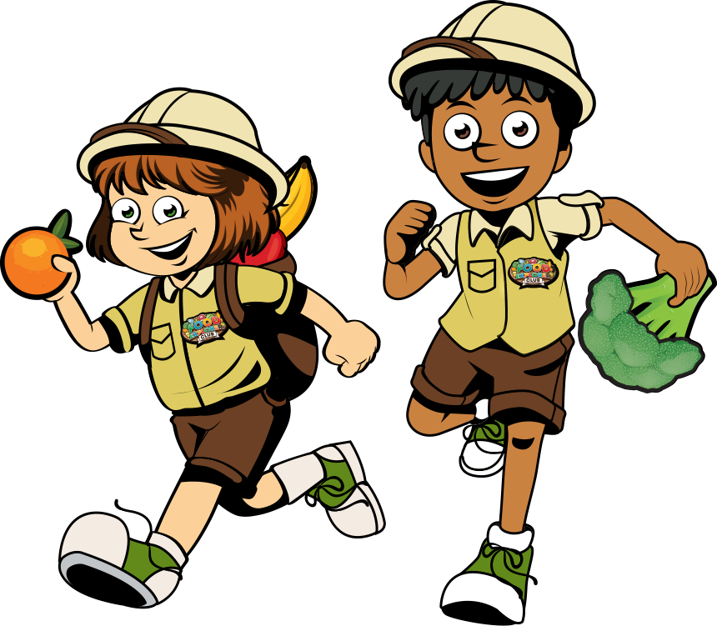
Autumn 1 (5 weeks)
Rationale
This project begins with an exciting visit to Avon Heath Country Park to learn some survival skills and the children discover how explorers build dens in order to survive during their outdoor expeditions. In Science, the children will learn about everyday materials and their suitability, conducting various tests and experiments to investigate their properties. They will use their scientific knowledge in Design and Technology to build a suitable den for a Lego explorer. In English the children will learn about different types of explorers (polar, air and underwater) and write their own adventure stories, diary entries and fact page about the real-life explorer Amelia Earhart. Finally, the children will create their own instructional videos on how to build a den.

Hook  The children are immersed in the project through a hands-on activity day at Avon Heath country park, which will include den building skills. |  |  | Outcome  Using their den-building knowledge, children to create a video of an instructional demonstration of how to build a den.
Key Texts
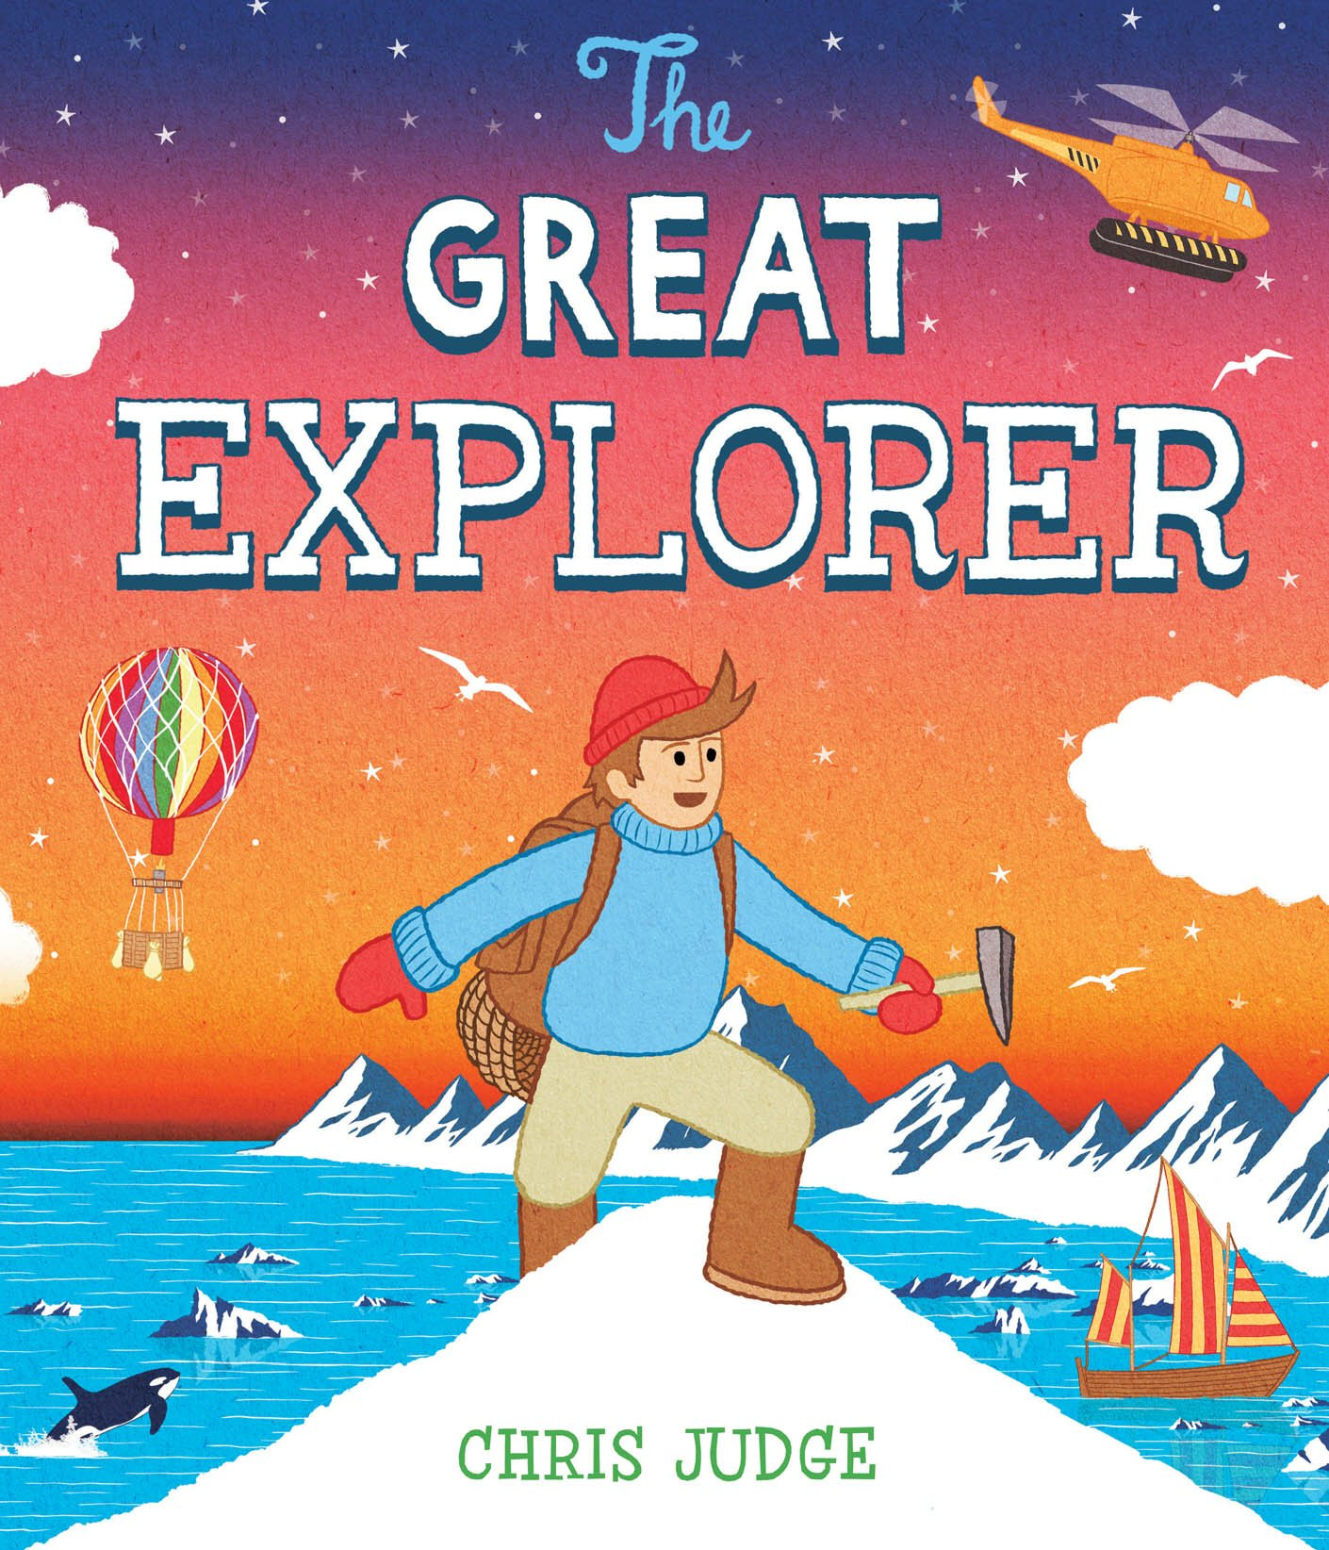  The Great Explorer – Chris Judge | 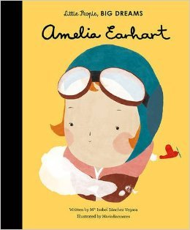  Amelia Earhart – Isabel Sanchez Vegara |  |  | 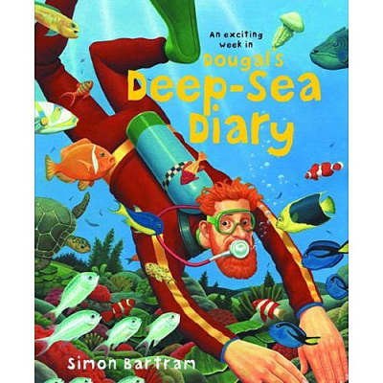  Dougal’s Deep Sea Diary – Simon Bartram |  | 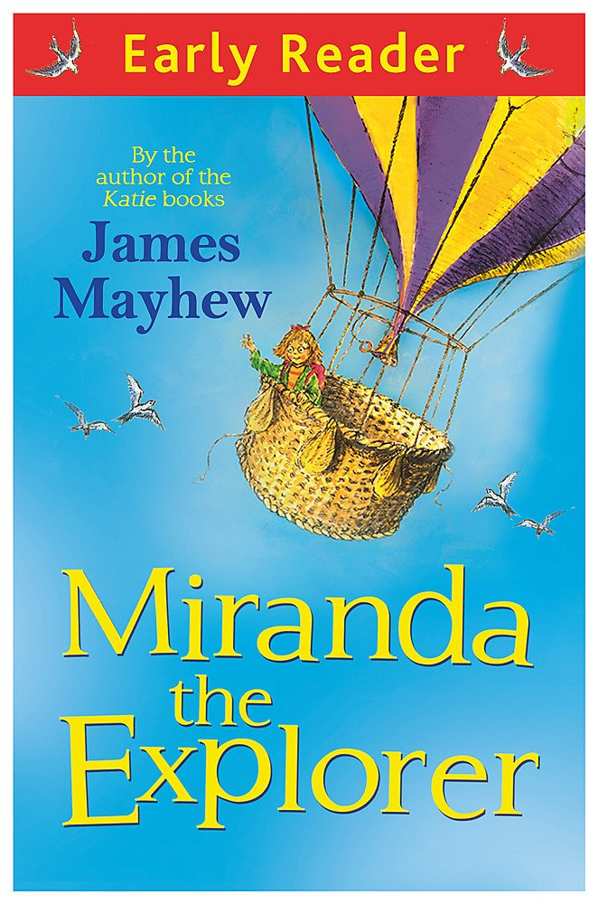  Miranda The Explorer – James Mayhew  Whole Class Reader
Focus Subject – English  - Write a recount of their Avon Heath den building experience using the past tense and suffix ‘ed’.  - Using the Little People, Big Dreams book and own research, create a fact page about the famous air explorer Amelia Earhart using questions and statements.  - Using ‘Dougal’s Deep Sea Diary’ write a diary entry using the past tense, the suffix ‘ed’ and exclamation marks.  - Using ‘The Great Explorer’ write their own adventure story using expanded noun phrases and the conjunction ‘and’.  - Write instructions for building a den using commands, imperative verbs and including adverbs with the suffix ‘ly’. |  | Focus Subject – Science  Materials Experiments:  Which materials are the most suitable for an explorer to use when building a den?  - Identify and compare the suitability of a variety of everyday materials.  - Find out how the shapes of solid objects made from some materials can be changed by squashing, bending, twisting and stretching.  - Asking simple questions and recognising that they can be answered in different ways  - Observing closely, using simple equipment.  - Performing simple tests.  - Identifying and classifying  - Using their observations and ideas to suggest answers to questions.  - Gathering and recording data to help in answering questions. |  |  | Focus Subject – Design & Technology  Children to design and create a den for a Lego explorer.  - Design purposeful, functional, appealing products for themselves and other users based on design criteria  - Generate, develop, model and communicate their ideas through talking, drawing, templates, mock-ups and, where appropriate information and communication technology.  - Select from and use a wide range of tools and equipment to perform practical tasks.  - Select from and use a wide range of materials and components, including construction materials, according to their characteristics.  - Evaluate their ideas and products against design criteria.  - Build structures, exploring how they can be made stronger, stiffer and more stable.
Application Subject – Computing
Children will create their own instructional videos of how to make a den.
Maths – The children will continue to recap and consolidate their place value knowledge of numbers to 100. They will use place value charts and part-whole models to support with this. They will order and compare numbers using the greater than, equal to and less than symbols (> < =). They will then recap counting in 2s, 5s and 10s before moving on to learning to count in 3s. The children will then move on to addition and subtraction. They will begin by adding and subtracting ones, finding 10 more and 10 less before moving on to adding or subtracting a one digit number from any two digit number using a variety of methods.
Home Learning – Research a famous explorer and create a poster about them.

Trips and Visitors – Den building experience at Avon Heath Country Park.

