**Christchurch Infant School**

*Addiscombe Road, Christchurch, Dorset, BH23 2AE*

*Telephone: (01202) 485851 Fax: (01202) 479149  
E-mail:* [*office@christchurchinf.dorset.sch.uk*](mailto:office@christchurchinf.dorset.sch.uk) ***Headteacher: Mr D Baxter***

***Deputy Headteacher: Mrs Simpson***

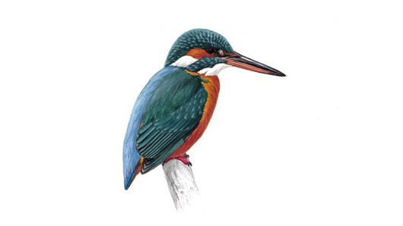 **Year 2: Hero Assembly - Thursday 2nd December 2021**

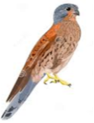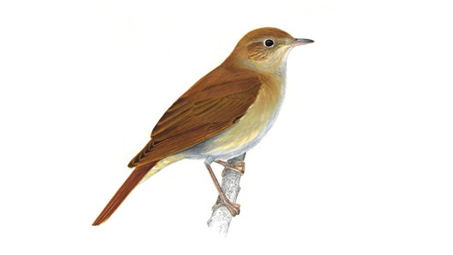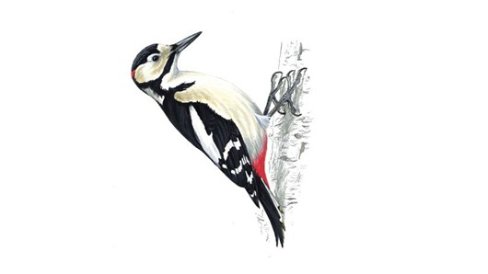

Dear Parents/carers,  
  
On Thursday 2nd December each class will be leading an assembly to honour heroes in our everyday life. Each child can choose to invite one adult, (a family member or friend) who they believe is a hero to them, to enjoy this special celebration.

The assemblies will take place at 2.30pm in the children’s classrooms.

Please return the slip below to your child’s class teacher.

Many thanks,

Year 2 Team

----------------------------------------------------------

Child’s name ____________________________________

Class _____________________

Invited hero’s name and relation to the child: _________________________________________________