Deadly Dinosaurs
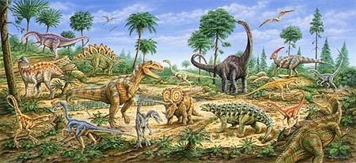
(7 weeks) Spring 1
Rationale
The Year 1 children come into class to find some strange footprints all over the classroom. Who do they belong to? Research will reveal that they are in fact dinosaur footprints and the children will be challenged to find out more about these prehistoric creatures and why they are so important to our local area. They will place the history of dinosaurs on a timeline and will discover the significance of Mary Anning and Lyme Regis. They will also design, create and evaluate their own moving vehicle in the form of a Jurassic Jeep. Finally, this will culminate in a race to see which jeep goes the furthest and a dinosaur museum to present learning to parents.
Hook  The Year 1 children will experience a dinosaur ‘wow’ day where they will learn about fossils and make their own clay fossils.  They will also visit the ‘Dinosaur Dome’ to learn key facts about dinosaurs and Mary Anning to spark their interest in the topic. |  |  | Outcome  A Jurassic Jeep Race, where children will test the Jeeps they have created to see which goes the furthest. This is followed by a Dinosaur museum for parents including art work, factual posters about Mary Anning and facts about dinosaurs.
Key Texts
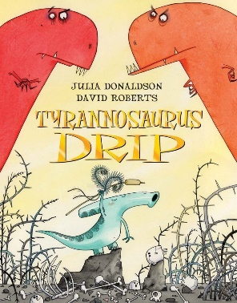  Tyrannosaurus Drip – Julia Donaldson | 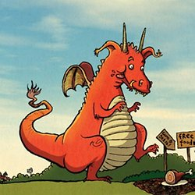  How To Trap a Dragon –  Pie Corbett |  | 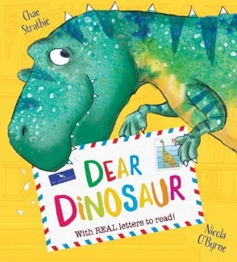  Dear Dinosaur –  Chae Stathrie |  | 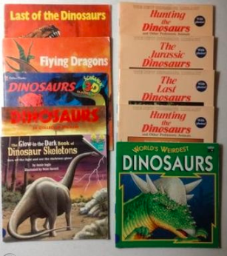  Non-fiction texts about dinosaurs
Focus Subject – English  - Use talk for writing to create a story map and retell a shortened version of Tyrannosaurus Drip including exclamation marks.  - Plan and write own dinosaur story using appropriate descriptive vocabulary.  - Write a set of innovated instructions on ‘How to Trap a Dinosaur’ based on the Pie Corbett text ‘How to Trap a Dragon’ including command sentences and time conjunctions.  - Write a letter to a dinosaur using the features of a letter including exclamation marks and question marks.  - Create a fact page about a dinosaur using features of a non-fiction text, past tense, plural suffixes and the suffix ‘ed’.  - Write dinosaur fact cards for the dinosaur museum using question marks. |  | Focus Subject – History  - Learn about significant historical events, people and places in their own locality. (Mary Anning and her fossil discoveries)  - Learn about the lives of significant individuals in the past who have contributed to national and international achievements. (Mary Anning)  - Learn about events beyond living memory that are significant nationally or globally. |  | Focus Subject – Design & Technology  Jurassic Jeeps  - design purposeful, functional, appealing products for themselves and others based on design criteria.  - Generate, develop, model & communicate their ideas through talking, drawing, templates, mock-ups and, where appropriate, ICT.  - Select from and use a range of tools and equipment to perform practical tasks [e.g cutting, shaping, joining & finishing]  - Select from and use a wide range of materials and components, including construction materials, textiles and ingredients, according to their characteristics  - Explore and evaluate a range of existing products  - Evaluate their ideas and products against design criteria  - Build structures, exploring how they can be made stronger, stiffer and more stable  - Explore and use mechanisms in their products.
Application Subject – Science
Children to identify which dinosaurs were carnivores, herbivores and omnivores. Children to compare and contrast different dinosaur’s bodies.
Application Subject – Geography
Using an aerial photo of the school, children are given directional instructions to find a dinosaur egg hidden around the school.
Home Learning – Children to research dinosaurs and create a fact file/model about their favourite dinosaur.
Trips and Visitors – Dinosaur Dome

