Red Word Games
Please find below a list of games that will help support your child read and write tricky words that cannot be decoded/sounded out.
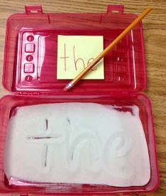
Writing in Sand
Put some sand in a small container and ask your child to write the red word with their finger, pencil or paintbrush. Can they copy the word and then have a go without looking?
Red Word Bingo
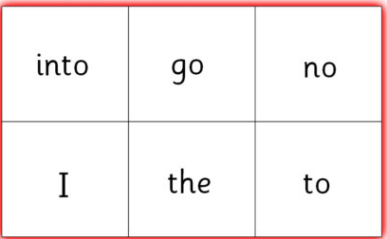
Make a bingo board for all players (see picture). Write some of the red words on to separate pieces of paper and put them in a bowl. Pick them up one by one and cross them off if they are on their bingo board.

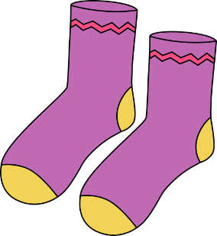
Splat the Word
Stick up some red words onto your wall/door and ask your child to splat the word you call out by throwing a pair of socks.

Red Word Treasure Hunt
Ask your child to write the red words they are learning on separate pieces of paper. Now hide the red words all around the garden or the house for your child to find and read out loud.

Red Word Hopscotch
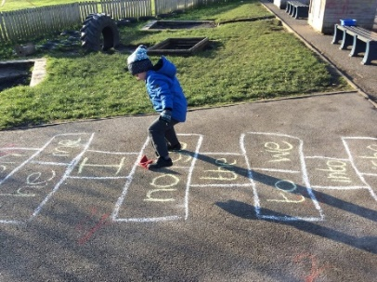
Draw a hopscotch with chalk, fill in the gaps with red words and your child can enjoy jumping along while saying the words out loud.

