Christchurch Infant School
Addiscombe Road, Christchurch, Dorset, BH23 2AE
Telephone: (01202) 485851 Fax: (01202) 479149
E-mail: office@christchurchinf.dorset.sch.uk
Headteacher: Mr D Baxter
Deputy Headteacher: Mrs Simpson
Year 1 Newsletter
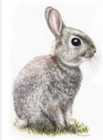
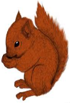

Dear Year 1 Parents/ Guardians,
Unfortunately, we cannot hold our usual ‘Dinosaur Museum’ event where parents view their children’s work from our ‘Walking with Dinosaurs’ topic. Due to the recent rise in COVID case numbers within school and the LFT testing procedure that is required to enter school, as a team we have decided it is safest to cancel this event. In order for the children to showcase their fabulous work they will be showing some year 2 children their work next Monday instead. We will take photographs of this event and video the exciting dinosaur jeep races which will then be uploaded on the school website as a blog for each class. Please have a look at the class blogs with your child so they can show off their newly learnt dinosaur knowledge.
Thank you for your understanding and co-operation at these ongoing difficult times.

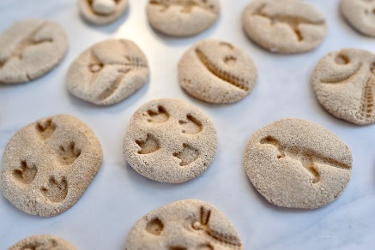
The Year 1 team

